INTEGRATIVE COURSE IN PSYCHOLOGY (ICOPSYCH)

ANALYSIS ON THE RESULT OF PRE-TEST EXAMINATION IN DEVELOPMENTAL PSYCHOLOGY
MAY 3, 2025

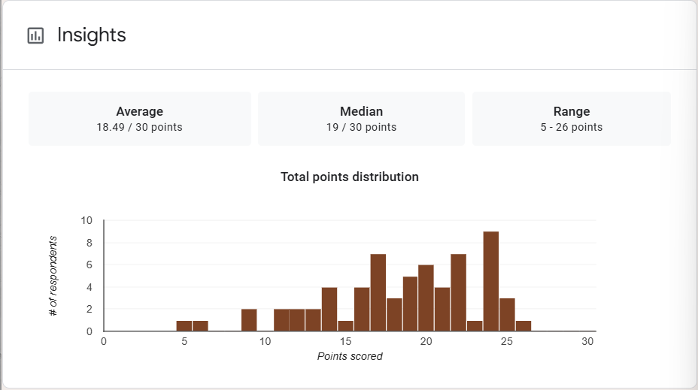

1. Mean Score: The mean is the average score across all test-takers. A score of 18.49 out of 30 translates to approximately 61.6%, which suggests that on average, students performed at a moderate level. This may indicate a test of medium difficulty or a mixed level of student understanding.

2. Median Score: The median score is the middle value when all scores are ordered. A median of 19 (63.3%) is slightly above the mean, which suggests a slight negative skew in the data. This means there may be a few lower scores pulling the average down, while the majority of students performed slightly better than the average.

3. Range: This wide range (21 points) indicates a high variability in student performance. Some students struggled significantly, while others performed very well.

Interpretation Summary:

-Average performance was moderate (~61.6%), with most students scoring around 63.3%.
-The data shows slight negative skewness, indicating a few low scores are dragging the average down.
-There is a wide range in scores (5 to 26), which implies diverse levels of understanding among students—some mastered the material well, while others had significant difficulty.
-Overall, the results suggest that while a fair number of students performed reasonably well, the test may require review for clarity, or additional instructional support might be needed for the lower-performing group.

RATIONALIZATION:

DIFFICULT QUESTIONS:

